MACH4METAL

metalworking machinery
Transito 21, 6909 DA Babberich, Netherlands
Tel. + 31 (0)316 – 247123
Fax. + 31 (0)316 - 247956

Bank No : 66.52.13.883
IBAN : NL33 INGB 0665 2138 83
BIC : INGBNL2A
VAT : NL 815393635B01

HYUNDAI SKT 21 LMS

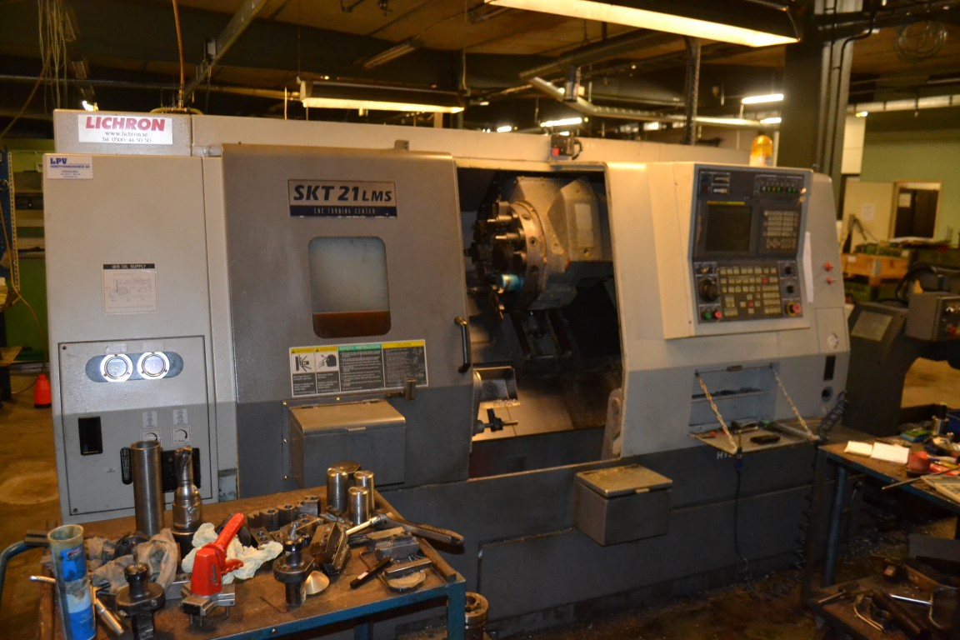
- Make : HYUNDAI KIA
- Type : SKT 21 LMS
- Age : 2006
- Serial : ….

- Swing over bed : 550
- Swing over saddle : 350
- DBC turning length : 530
- Spindle bore : 110
- Spindle speeds : 4.000
- Max. chuck size : 210
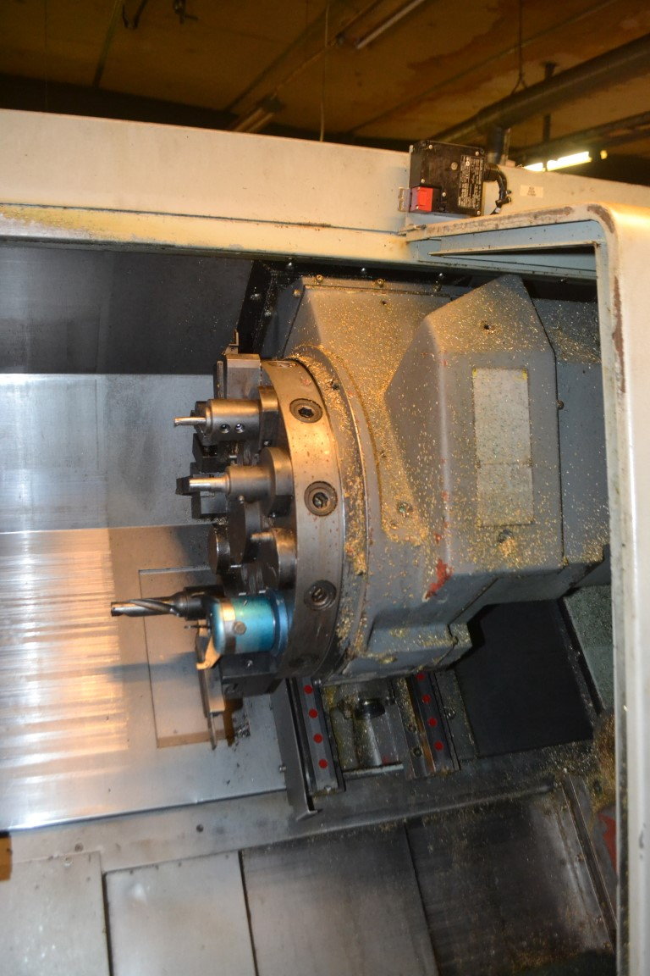

- Max. chuck size sub spindle : 135
- Spindle speeds : 6.000
- Spindle bore : 60
- Power sub spindle : 3.7 kW

- Revolver 12 Positions
- Speeds live tool : 4.000
- Rapid feed rate X/Z : 36.000
- Rapid feed rate B : 30.000

- X Axis Travel : 210
- Z Axis Travel : 550
- C Axis : 360.000
- B Axis Travel : 750
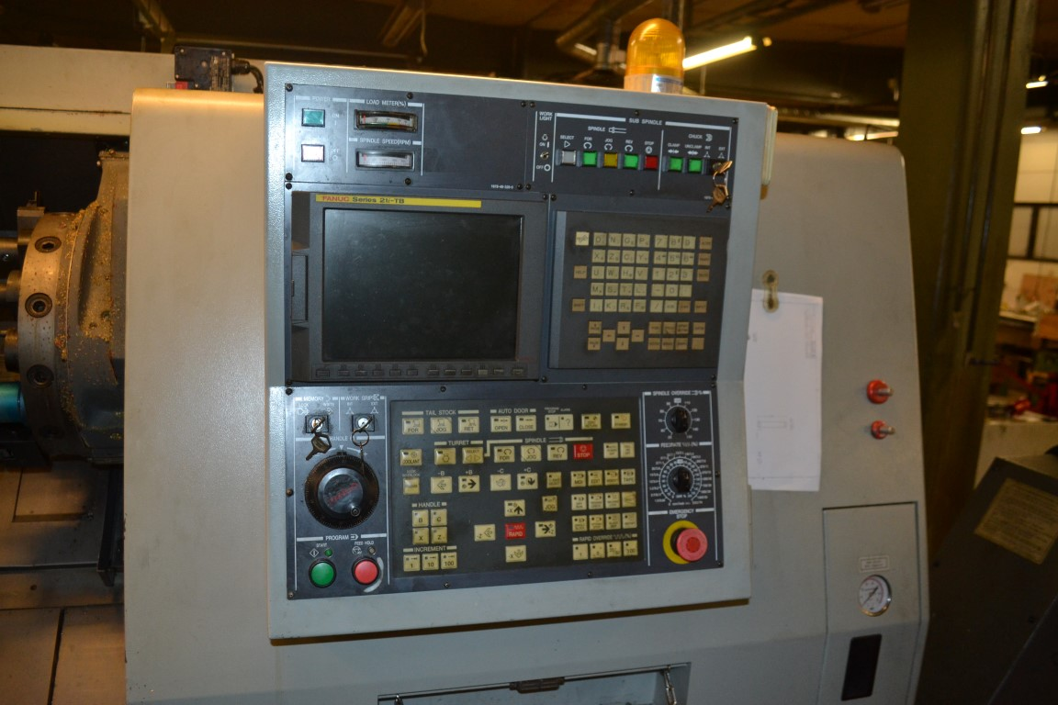

- Dimensions
- Length : 3150
- Width : 1650
- Height : 1870
- Weight : 4400

- CNC Control FANUC 21 iTB
- Chip conveyor

Please Note: The above information has been obtained to the best of our ability and belief from, and from the manufacturers where possible. It is given in good faith, but its accuracy can not be guaranteed. Accordingly, it will not form a representation or constitute contractual terms. We advise you to check any vital details!

